Project Design Phase-II
Technology Stack (Architecture & Stack)

Date
Team ID | LTVIP2026TMIDS45779
Project Name | Electric Motor Temperature Prediction Using Meachine Learning
Maximum Marks | 4 Marks

Technical Architecture:
Electric Motor Temperature Prediction System
Reference: https://developer.ibm.com/patterns/ai-powered-backend-system-for-order-processing-during-pandemics/

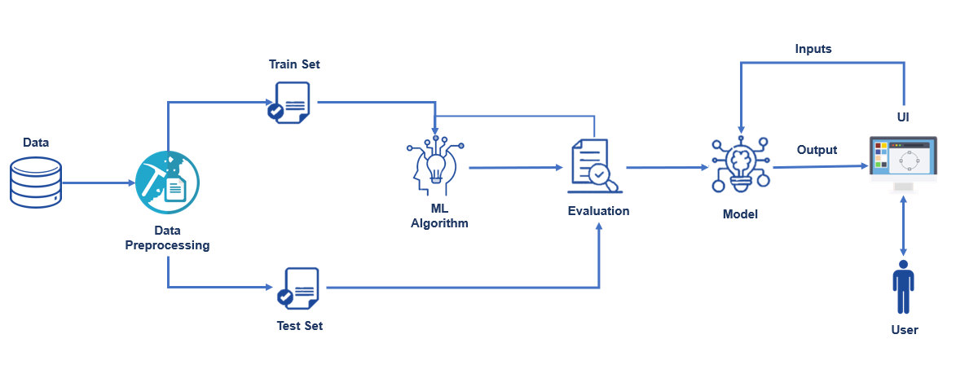

Table-1: Components & Technologies:
S.No | Component | Description | Technology
1 | User Interface | Web interface where users enter motor parameters (ambient, coolant, voltage, current) and receive prediction results | HTML, CSS
2 | Application Logic-1 | Backend processing logic to receive form input and handle requests | Python (Flask Framework)
3 | Application Logic-2 | Data preprocessing logic (scaling input features before prediction) | Scikit-learn (MinMaxScaler)
4 | Application Logic-3 | Machine learning prediction logic | Random Forest Regressor (Scikit-learn)
5 | Database | Not required for current version (static ML model prediction). Can be extended for storing logs/history | Optional: MySQL / SQLite
6 | Cloud Database | Not implemented currently (Future scope for cloud logging) | IBM Cloudant / AWS RDS (Future Enhancement)
7 | File Storage | Storage of trained ML model and scaler files | Joblib (.save files) stored in Local File System
8 | External API-1 | Dataset source for training | Kaggle Electric Motor Temperature Dataset
9 | External API-2 | Not used currently (Can integrate IoT sensor API in future) | IoT Sensor API (Future)
10 | Machine Learning Model | Predict Permanent Magnet (PM) surface temperature based on motor parameters | Random Forest Regression Model
11 | Infrastructure (Server / Cloud) | Application deployed locally for demo and academic use | Local Server (Flask Development Server), VS Code

Table-2: Application Characteristics
S.No | Characteristics | Description | Technology
1 | Open-Source Frameworks | Frameworks and libraries used for development and ML implementation | Flask, Scikit-learn, Pandas, NumPy
2 | Security Implementations | Input validation on form fields, local hosting, debug control, protection against invalid data | Flask validation, Python exception handling
3 | Scalable Architecture | Modular design separating UI, preprocessing, ML model, and backend. Can be extended to microservices architecture | Flask (3-tier structure possible), REST API (Future)
4 | Availability | Currently single-instance local server. Can be deployed to cloud with high availability setup | AWS EC2 / Azure / IBM Cloud (Future Scope)
5 | Performance | Fast prediction (single inference < 1 second). Model preloaded at server start. No retraining required during runtime | Random Forest Model, Preloaded Joblib Model

References:
https://c4model.com/
https://developer.ibm.com/patterns/online-order-processing-system-during-pandemic/
https://www.ibm.com/cloud/architecture
https://aws.amazon.com/architecture
https://medium.com/the-internal-startup/how-to-draw-useful-technical-architecture-diagrams-2d20c9fda90d

